InsightStream: Navigate the News Landscape

# Introduction

* + **Project Title: InsightStream: Navigate the News Landscape**
  + **Team ID: NM2025TMID42260**
  + **Team Leader:**
    - MITHRA S & [mithrasubramani19@gmail.com](mailto:mithrasubramani19@gmail.com)
  + **Team Members:**
    - NITHEESHWARI P & [nitheeshwarinithiyasri@gmail.com](mailto:nitheeshwarinithiyasri@gmail.com)
    - PAVITHRA R & [pavithraramesh0705@gmail.com](mailto:pavithraramesh0705@gmail.com)
    - PRIYADHARSHINI P & [priyadharshinikarthik2006@gmail.com](mailto:priyadharshinikarthik2006@gmail.com)

# Project Overview

* + **Purpose:** InsightStream is a comprehensive news aggregation and analysis platform that helps users navigate the complex media landscape by providing personalized content, bias detection, and trend analysis.
  + **Features:**
* Multi-source news aggregation from reputable publishers
* Media bias indicator and transparency scoring
* Personalized news feed based on user preferences
* Topic trend visualization and analytics
* Save articles and create reading lists
* Cross-platform accessibility (web and mobile)

# Architecture

* + **Frontend:** React.js with Tailwind CSS and Chart.js for visualizations
  + **Backend:** Node.js and Express.js managing news API integrations and user data
  + **Database:** MongoDB stores user profiles, saved articles, preferences, and analytics
  + **External APIs:** NewsAPI, Media Bias/Fact Check integration, Natural Language Processing services

# Setup Instructions

* + **Prerequisites:**
* Node.js (v16 or higher)
* MongoDB Atlas account or local installation
* Git
* NewsAPI key (free tier available)
* Visual Studio Code (recommended)
* **Installation Steps:**

```bash

# Clone the repository

git clone https://github.com/insightstream/news-platform.git

# Install client dependencies cd client

npm install

# Install server dependencies cd ../server

npm install

# Set up environment variables cp .env.example .env

# Add your API keys to the .env file

```

# Folder Structure

```

InsightStream/

|-- client/ # React frontend

| components/ # Reusable UI components

| pages/ # Application pages

| hooks/ # Custom React hooks

| utils/ # Helper functions

|-- server/ # Node.js backend

| routes/ # API route handlers

| models/ # MongoDB schemas

| controllers/ # Business logic

| middleware/ # Custom middleware

|-- docs/ # Project documentation

```

# Running the Application

* + Frontend:

```bash cd client npm start

```

* + Backend:

```bash cd server

npm run dev

```

* + Access: Visit [http://localhost:3000](http://localhost:3000/)

# API Documentation

* + User Management:
* POST /api/user/register - Create new account
* POST /api/user/login - Authenticate user
* GET /api/user/profile - Get user profile
* News Content:
  + GET /api/news/feed - Retrieve personalized news feed
  + GET /api/news/search?q=query - Search news articles
  + GET /api/news/sources - Get available news sources
* User Preferences:
  + POST /api/preferences - Save user preferences
  + GET /api/preferences - Retrieve user preferences
* Saved Content:
  + POST /api/saved - Save article to reading list
  + GET /api/saved - Retrieve saved articles
  + DELETE /api/saved/:id - Remove saved article

# Authentication

* + JWT-based authentication for secure login
  + Protected routes for user-specific content
  + Password hashing with bcrypt

# G. User Interface

* + **Landing Page:** Overview of platform features and trending stories
  + **Personalized Dashboard:** Custom news feed based on user preferences
  + **Source Analysis Page:** Media bias information and source reliability ratings
  + **Search Results Page:** Filtered news content with various sorting options
  + **User Profile Page:** Account settings and reading history

# Testing

* Unit testing with Jest and React Testing Library
* API testing with Postman
* End-to-end testing with Cypress
* Cross-browser compatibility testing

# Screenshots or Demo

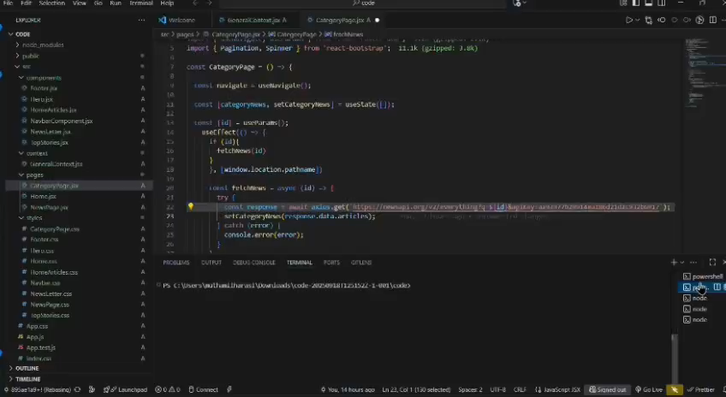

1. **Known Issues**
   * Occasional latency in news API responses during peak times
   * Limited news sources in certain regional markets
   * Mobile app still in development (web version fully functional)

# Future Enhancements

* + Browser extension for quick news verification
  + Advanced sentiment analysis of news content
  + Social features for sharing and discussing articles
  + Podcast integration and audio news briefings
  + Multilingual support for international users